**DATA COMMUNICATION AND NETWORKS LAB**

**FALL 2024**

**PROJECT REPORT**



**College network System**

Group members:

Ahmed Ali 22K-4937

Amir Abbasi 22K-4823

Abdullah Irshad 22K-4886

Submitted to: Engr. Zakir Hussain

Department of Electrical Engineering

National University of Computer and Emerging Sciences-FAST

Karachi Campus

|  |  |  |
| --- | --- | --- |
| **S.NO** | **TABLE OF CONTENTS** | **PAGE. NO** |
| **1** | **Introduction** | **3** |
| **2** | **Ip routing table** | **3-4** |
| **3** | **Overview** | **2** |
| **4** | **Working** | **4** |
| **5** | **Network Design** | **4** |
| **6** | **Configuration** | **5** |
| **7** | **Conclusion** | **12** |

1. **INTRODUCTION:**

This project demonstrates the design and implementation of a structured computer network for an organization using Cisco Packet Tracer. The network consists of multiple departments, each with its own subnet, interconnected through routers and switches. The primary objective of the project is to provide an efficient and secure communication infrastructure, allowing seamless file sharing, web hosting, and domain name resolution. The use of servers, including **FTP, DNS**, and **Web Servers,** further enhances the functionality of the network by offering centralized service

**IP Addressing Plan**

|  |  |
| --- | --- |
| **EE DEPARTMENT (192.168.1.0)** | |
| HOD CABIN | 192.168.1.2 |
| IT LAB 1 | 192.168.1.3 |
| IT LAB 2 | 192.168.1.4 |
| IT LAB 3 | 192.168.1.5 |
| IT LAB 4 | 192.168.1.6 |
| Printer 0 | 192.168.1.7 |

|  |  |
| --- | --- |
| **COMPUTER DEPARTMENT (192.168.2.0)** | |
| CS HOD CABIN | 192.168.2.2 |
| CS LAB 1 | 192.168.2.3 |
| CS LAB 2 | 192.168.2.4 |
| CS LAB 3 | 192.168.2.5 |
| CS LAB 4 | 192.168.2.6 |
| Printer 7 | 192.168.2.7 |

|  |  |
| --- | --- |
| **OTHERS (192.168.3.0)** | |
| OFFICE | 192.168.3.2 |
| Printer 2 | 192.168.3.6 |
| EXAM CELL | 192.168.3.3 |
| Printer 3 | 192.168.3.7 |
| ENQUIRY | 192.168.3.4 |
| TPO | 192.168.3.5 |
| Printer 4 | 192.168.3.8 |

|  |  |
| --- | --- |
| **SERVER ROOM (1.0.0.0)** | |
| FTP SERVER | 1.0.0.4 |
| PC1 | 1.0.0.5 |
| DNS SERVER | 1.0.0.2 |
| WEB SERVER | 1.0.0.3 |

|  |  |
| --- | --- |
| **LAB (128.168.0.0)** | |
| PC2 | 128.168.0.2 |
| PC3 | 128.168.0.3 |
| PC4 | 128.168.0.4 |
| PC5 | 128.168.0.5 |
| Printer 5 | 128.168.0.6 |

|  |  |
| --- | --- |
| **FACULTY ROOM (192.168.4.0)** | |
| PC 0 | 192.168.4.2 |
| LAPTOP 0 | 192.168.4.3 |

1. **OVERVIEW:**

* **Departments/Subnets**
* **EE Department (192.168.1.0/24):**
  + Includes PCs, printers, and other devices for the Electrical Engineering team.
* **Computer Department (192.168.2.0/24):**
  + Hosts PCs and printers for computational tasks.
* **Lab (128.168.0.0/24):**
  + Equipped with PCs and printers for student use.
* **Faculty Room (192.168.4.0/24):**
  + Contains laptops and PCs for faculty members.
* **Server Room (1.0.0.0/24):**
  + Houses the FTP Server, DNS Server, and Web Server to provide centralized services.
* **Other Departments (192.168.3.0/24 and 10.10.0.0/24):**
  + Additional networks with PCs and printers for administrative and operational tasks.
* **Servers**
  + **FTP Server (1.0.0.4):**
    - Provides file sharing capabilities across the network.
  + **DNS Server (1.0.0.2):**
    - Resolves domain names to IP addresses for easier navigation and communication.
  + **Web Server (1.0.0.3):**
    - Hosts web pages and applications accessible by users across the network.
* **Interconnection Devices**
  + Routers:
  + Connect different subnets and implement dynamic routing (RIP).
  + Switches:
  + Enable communication within each department’s subnet.
  + End Devices
  + Include PCs, laptops, and printers distributed across departments for organizational tasks

1. **WORKING:**

The routers interconnect all departments, ensuring that devices in different subnets can communicate. The **Routing Information Protocol (RIP)** is implemented to dynamically exchange route information between routers, simplifying routing table updates and maintaining efficient traffic flow.

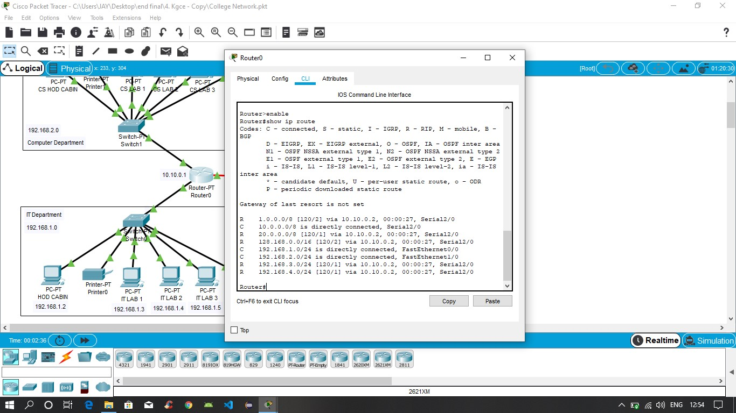

Routing Protocol Plan for Router0

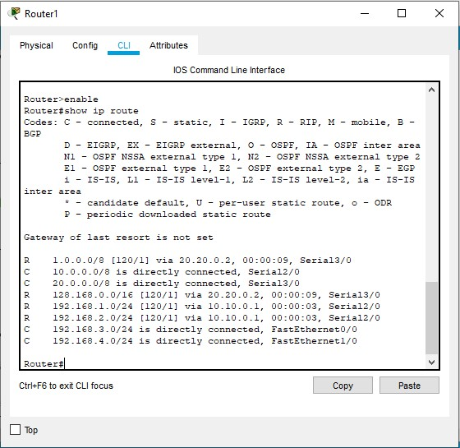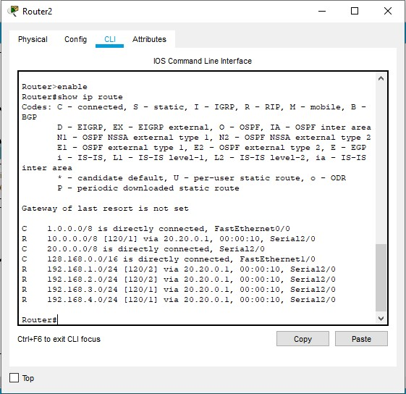

Routing Protocol Plan for Router1Routing Protocol Plan for Router2

**4.** **Network Design**

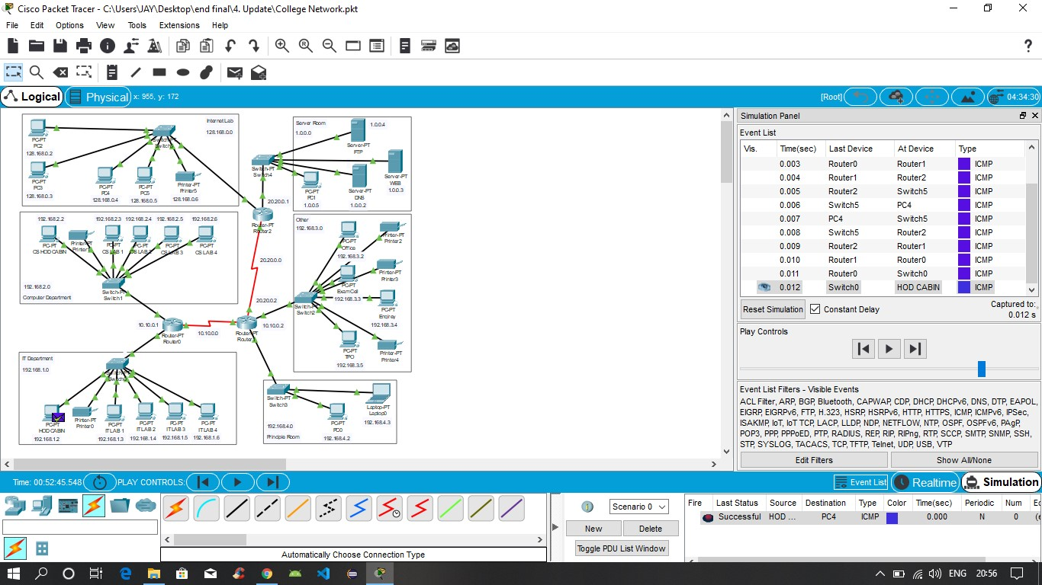

The prototype of the proposed network is implemented on cisco packet tracer

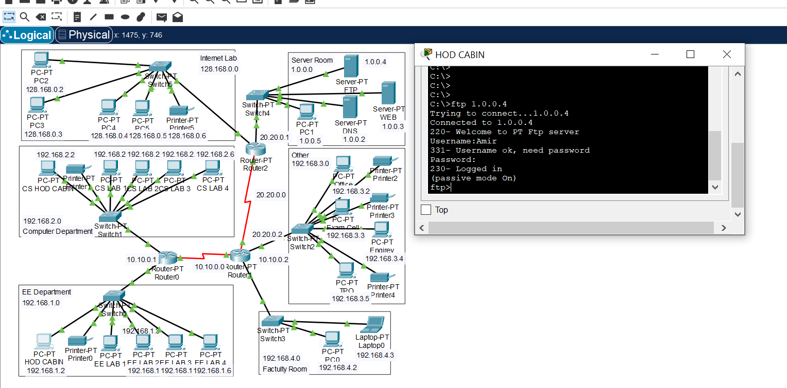

Testing VLAN communications from HOD Cabin to Internet Lab

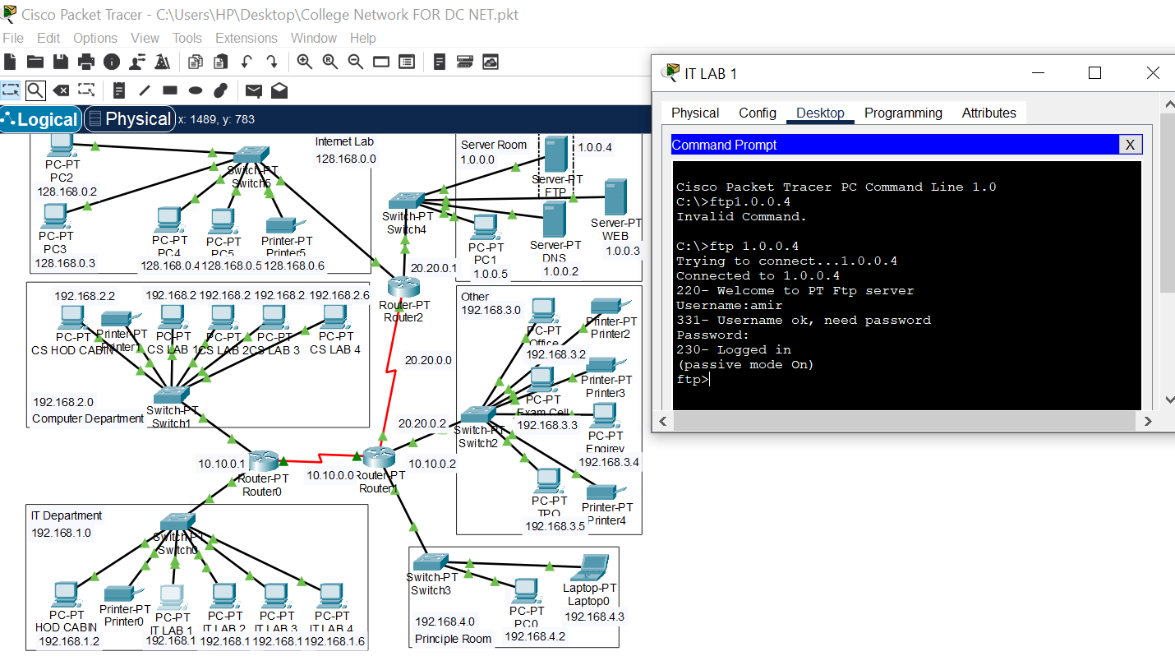

Testing FTP Server

**5.Router Configuration**

**Router0 Configuration**

1. Set the hostname as Router0.
2. Configure IP addresses for the interfaces:
   * **FastEthernet0/0**: IP 10.10.0.1, Subnet Mask 255.255.255.0
   * **FastEthernet0/1**: IP 192.168.1.1, Subnet Mask 255.255.255.0
3. Enable the interfaces using the no shutdown command.
4. Activate the RIP protocol and add the networks:
   * Network 10.10.0.0
   * Network 192.168.1.0

**Router1 Configuration**

1. Set the hostname as Router1.
2. Configure IP addresses for the interfaces:
   * **FastEthernet0/0**: IP 10.10.0.2, Subnet Mask 255.255.255.0
   * **FastEthernet0/1**: IP 192.168.2.1, Subnet Mask 255.255.255.0
3. Enable the interfaces using the no shutdown command.
4. Activate the RIP protocol and add the networks:
   * Network 10.10.0.0
   * Network 192.168.2.0

**Router2 Configuration**

1. Set the hostname as Router2.
2. Configure IP addresses for the interfaces:
   * **FastEthernet0/0**: IP 20.20.0.1, Subnet Mask 255.255.255.0
   * **FastEthernet0/1**: IP 1.0.0.1, Subnet Mask 255.255.255.0
3. Enable the interfaces using the no shutdown command.
4. Activate the RIP protocol and add the networks:
   * Network 20.20.0.0
   * Network 1.0.0.0

**Switch Configuration**

1. No additional configuration is required for switches as they operate at Layer 2.
2. Ensure all devices in each subnet are connected to the appropriate switch.
3. Assign VLANs if necessary (optional for this setup).

**Server Configuration**

**FTP Server**

1. Assign IP address 1.0.0.4 with Subnet Mask 255.255.255.0 and Gateway 1.0.0.1.
2. Enable the **FTP Service** from the Services tab in the server configuration.

**DNS Server**

1. Assign IP address 1.0.0.2 with Subnet Mask 255.255.255.0 and Gateway 1.0.0.1.
2. Enable the **DNS Service** from the Services tab and add the following mappings:
   * Example: www.organization.com -> 1.0.0.3 (Web Server IP).

**Web Server**

1. Assign IP address 1.0.0.3 with Subnet Mask 255.255.255.0 and Gateway 1.0.0.1.
2. Enable the **HTTP Service** from the Services tab.
3. Add files to the Web Server (e.g., index.html or custom pages).

**End Device Configuration**

1. Assign IP addresses to PCs, laptops, and printers within their respective subnets.
2. Configure the Default Gateway for each device:
   * EE Department: Gateway 192.168.1.1
   * Computer Department: Gateway 192.168.2.1
   * Lab: Gateway 128.168.0.1
   * Server Room: Gateway 1.0.0.1

**Sustainable Development Goal: Quality Education (SDG 4):**

This project embodies SDG 4 by leveraging technology to create an inclusive, collaborative, and resource-rich educational environment. Through an efficient network design, it empowers students and educators, enhancing the overall quality of education and fostering lifelong learning

**6. CONCLUSION:**

VoIP (Voice over Internet Protocol) has revolutionized communication by providing a flexible, cost-effective, and feature-rich alternative to traditional telephony. By leveraging the power of the internet, it enables seamless voice and multimedia communication across the globe, benefiting both personal and professional users. Despite challenges like dependency on internet quality and security concerns, advancements in technologies such as 5G, AI, and blockchain are continually enhancing its reliability and capabilities. VoIP is not just a replacement for conventional telephony but a cornerstone for modern, integrated communication systems, ensuring it remains essential in the evolving digital landscape.